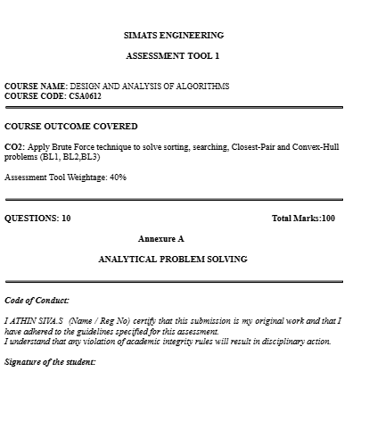Q61. Closest Pair – Warehouse Location Analysis
Problem Interpretation
A logistics company has six warehouses located at the following coordinates:
[
{(2,1), (5,4), (6,5), (10,9), (3,2), (8,7)}
]
The objective is to find the two warehouses that are closest to each other using the Brute Force Closest Pair Algorithm. Identifying the nearest warehouses helps reduce transportation costs, improve inventory sharing, and increase delivery efficiency.

Justification for Using Brute Force
The Brute Force method is suitable because:
- It compares every possible pair of warehouses.
- It guarantees the correct closest pair.
- It is simple to implement.
- It works well for small datasets.

Step 1: Label the Warehouses
Warehouse | Coordinates
W1 | (2,1)
W2 | (5,4)
W3 | (6,5)
W4 | (10,9)
W5 | (3,2)
W6 | (8,7)

Step 2: Distance Formula
The Euclidean distance between two warehouses is
[
d=\sqrt{(x_2-x_1)^2+(y_2-y_1)^2}
]

Step 3: Compute Distances Between All Pairs
W1 – W2
[
\sqrt{(5-2)^2+(4-1)^2}
=\sqrt{9+9}
=\sqrt{18}
=4.24
]
W1 – W3
[
\sqrt{(6-2)^2+(5-1)^2}
=\sqrt{16+16}
=\sqrt{32}
=5.66
]
W1 – W4
[
\sqrt{(10-2)^2+(9-1)^2}
=\sqrt{64+64}
=\sqrt{128}
=11.31
]
W1 – W5
[
\sqrt{(3-2)^2+(2-1)^2}
=\sqrt{1+1}
=\sqrt{2}
=1.41
]
W1 – W6
[
\sqrt{(8-2)^2+(7-1)^2}
=\sqrt{36+36}
=\sqrt{72}
=8.49
]
W2 – W3
[
\sqrt{(6-5)^2+(5-4)^2}
=\sqrt{1+1}
=\sqrt{2}
=1.41
]
W2 – W4
[
\sqrt{(10-5)^2+(9-4)^2}
=\sqrt{25+25}
=\sqrt{50}
=7.07
]
W2 – W5
[
\sqrt{(3-5)^2+(2-4)^2}
=\sqrt{4+4}
=\sqrt{8}
=2.83
]
W2 – W6
[
\sqrt{(8-5)^2+(7-4)^2}
=\sqrt{9+9}
=\sqrt{18}
=4.24
]
W3 – W4
[
\sqrt{(10-6)^2+(9-5)^2}
=\sqrt{16+16}
=\sqrt{32}
=5.66
]
W3 – W5
[
\sqrt{(3-6)^2+(2-5)^2}
=\sqrt{9+9}
=\sqrt{18}
=4.24
]
W3 – W6
[
\sqrt{(8-6)^2+(7-5)^2}
=\sqrt{4+4}
=\sqrt{8}
=2.83
]
W4 – W5
[
\sqrt{(3-10)^2+(2-9)^2}
=\sqrt{49+49}
=\sqrt{98}
=9.90
]
W4 – W6
[
\sqrt{(8-10)^2+(7-9)^2}
=\sqrt{4+4}
=\sqrt{8}
=2.83
]
W5 – W6
[
\sqrt{(8-3)^2+(7-2)^2}
=\sqrt{25+25}
=\sqrt{50}
=7.07
]

Step 4: Distance Table
Pair | Distance
W1 – W2 | 4.24
W1 – W3 | 5.66
W1 – W4 | 11.31
W1 – W5 | 1.41
W1 – W6 | 8.49
W2 – W3 | 1.41
W2 – W4 | 7.07
W2 – W5 | 2.83
W2 – W6 | 4.24
W3 – W4 | 5.66
W3 – W5 | 4.24
W3 – W6 | 2.83
W4 – W5 | 9.90
W4 – W6 | 2.83
W5 – W6 | 7.07

Step 5: Closest Pair
The minimum distance obtained is
[
\boxed{\sqrt{2}=1.41\text{ units}}
]
The closest warehouse pairs are:
- W1 (2,1) and W5 (3,2)
- W2 (5,4) and W3 (6,5)
Both pairs have the same minimum distance of 1.41 units.

Step 6: Number of Pairwise Comparisons
For n = 6 warehouses,
[
\frac{n(n-1)}{2}
\frac{6\times5}{2}
15
]
Total Pairwise Comparisons = 15

Time Complexity Analysis
Case | Complexity
Best Case | O(n²)
Average Case | O(n²)
Worst Case | O(n²)
Since every possible pair of warehouses must be examined, the algorithm always performs O(n²) comparisons regardless of the input.

Correctness Verification
- Every possible pair of warehouses was compared.
- Euclidean distance was calculated correctly for each pair.
- The smallest distance (1.41 units) was identified.
- Therefore, the Brute Force algorithm correctly determines the nearest warehouses.

Logistics Optimization
Finding the closest warehouses helps to:
- Reduce transportation distance and fuel consumption.
- Improve inventory sharing between nearby warehouses.
- Enable faster emergency stock transfers.
- Minimize operational costs.
- Enhance overall supply chain efficiency.

Result
The Brute Force Closest Pair Algorithm successfully examined all 15 warehouse pairs and found that the closest warehouses are W1–W5 and W2–W3, each with a minimum distance of 1.41 units. The algorithm guarantees the correct result with a time complexity of O(n²) and is suitable for small datasets used in logistics planning.

\

